Solution:

All the TCP handshake requests are initiated by 172.163.40.138. It chooses a random port and increments for subsequent requests. The request is always made to 172.16.40.134 on port 443.

After analyzing the file using wire shark; tried to decode the TCP to other formats like IMAP, SSH, DNS etc. I saw some changes; however I could not retrieve any message from it. IMAP made most sense when the SSH Continuous data got transformed to Requests and responses

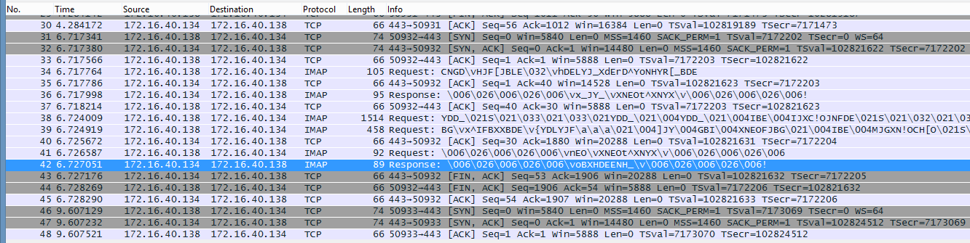

To begin with snort rules I would expect the header part to e as below:

**Alert tcp 172.163.40.138 any -> 172.16.40.134 443 (msg:”ALERT! Assignment 5 - Connection Initiation! “; flags: s; sid:1000001);**

Fields:

|  |  |  |
| --- | --- | --- |
| Action: | **Alert** | because we need an alert to pop up when a snort rule matches |
| Protocol: | **tcp** | because the protocol under analysis from the given pcap is TCP |
| SRC IP adderess : | **172.163.40.138** | because the TCP handshake is being initiated by 172.163.40.138 |
| SRC port : | **any** | because in the pcap 172.163.40.138 chooses a random port and increases the port number for subsequent requests |
| Direction operator: | **->** | direction of traffic for this rule |
| Dest IP : | **172.16.40.134** | TCP request is made to 172.16.40.134 from the source |
| Dest port: | **443** | port for 172.16.40.134 |
| Msg: | **ALERT! Assignment 5 - Connection Initiation** | Message to be displayed |
| Flags : | **S** | because we want to check for the case when the flag is set to SYN |
| Sid : | **1000001** | Assign a Snort id to the rule |

This above rule would give an alert when 172.163.40.138 tries to initiate a connection to 172.16.40.134 on port 443.

**alert tcp 172.16.40.138 any -> 172.16.40.134 443 (msg:”ALERT! Fishy request packet “; sid:1000005; content:"|43 4E 47 44|"; rawbytes;)**

I noticed that all the initial request packets have a common repeating text “CNGD” hence we search the hex equivalent 43 4E 47 44 in raw bytes.

The above rule gives an alert when the first request packet is sent.